**Exploration Data with Excel**

Load and Clean the Data

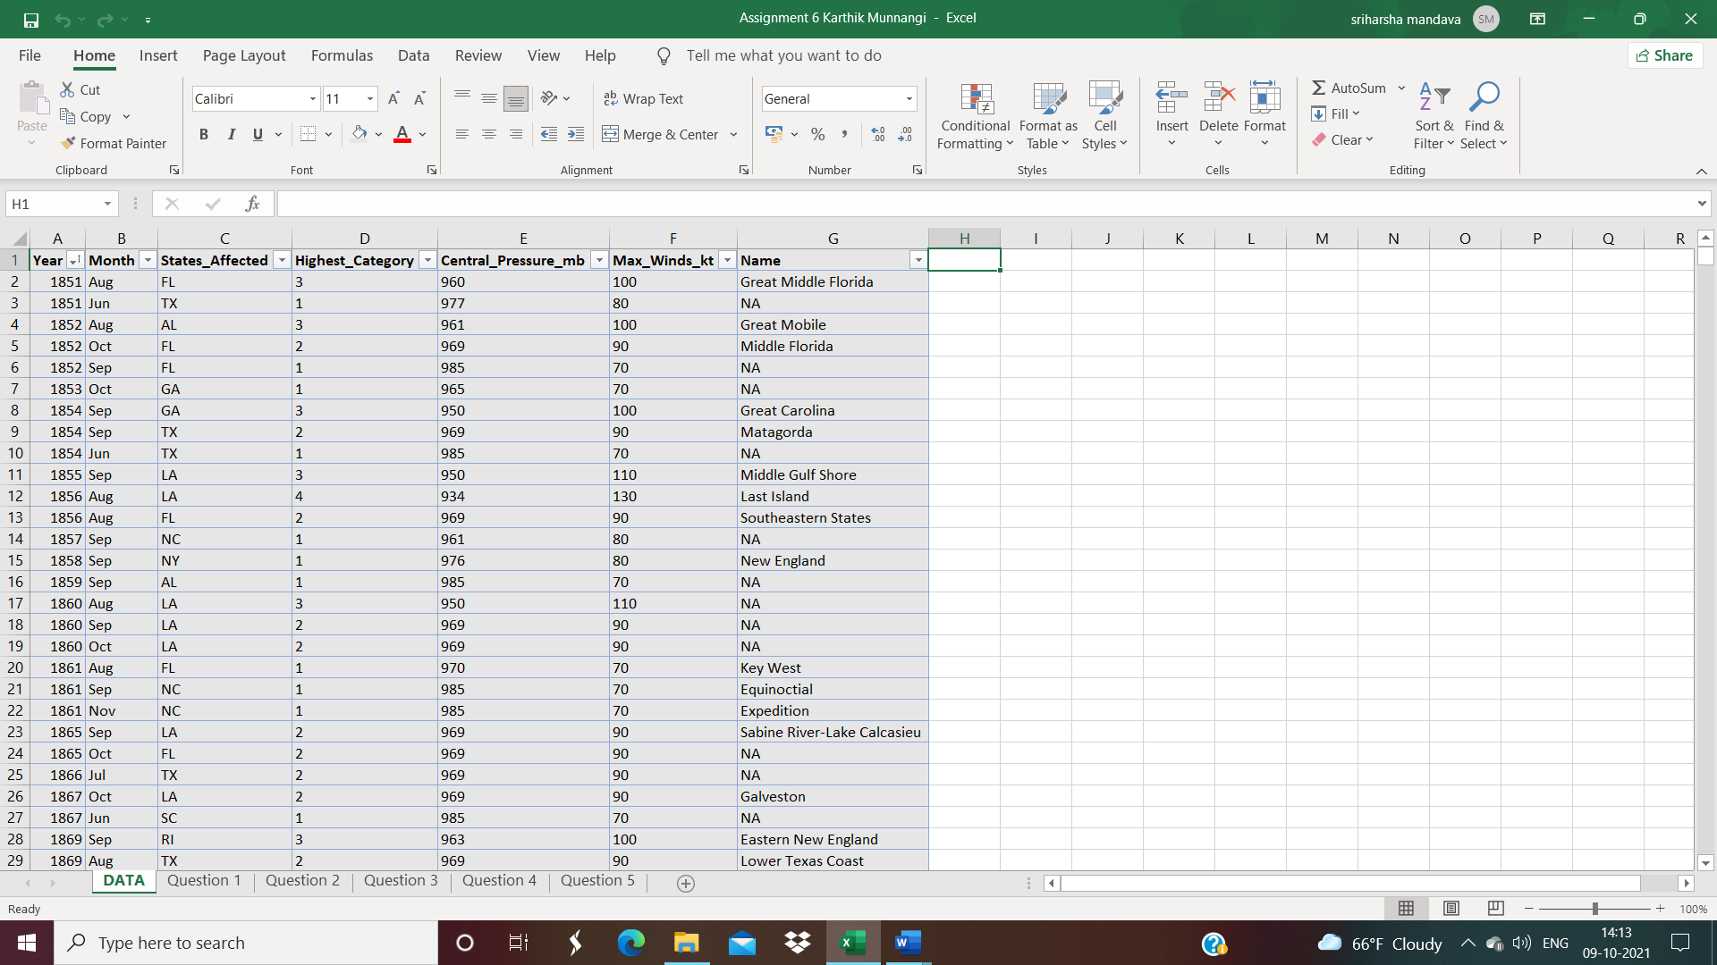

1. **The number of hurricanes for each month**

In the above plot I have visualized the number of hurricanes in every month of a year.

1. **The frequency of highest categories**

|  |  |
| --- | --- |
| **Row Labels** | **Count of Highest_Category** |
| 1 | 109 |
| 2 | 74 |
| 3 | 75 |
| 4 | 18 |
| 5 | 3 |
| TS | 2 |
| **Grand Total** | **281** |

In the above I have visualized Frequency of highest category hurricanes with respect to number of hurricanes.

1. **The range, mean, and median for central pressure and for max winds**

I have visualized the Minimum, Maximum, the mean, median, and rage of the central pressure and Max Winds.

1. **The relationship between central pressure and max winds**

The plot represents the maximum winds and the pressures during hurricanes.

1. **The frequency of occurrence for each state.**

Plot represents the frequencies of occurrence of hurricanes in each state.